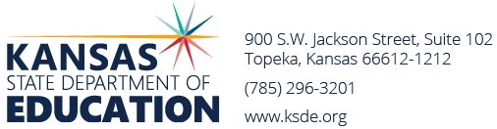
Revised Feb 15, 2023
2023-24 Bonds Requested

2022-2023 Bonds Retired + PPI (Cap) = $607,123,770

USD | District Name | Election Date | Amount Requested | * Amount Against Cap
205 | Bluestem | 8/29/23 | 13,515,000 | 0
219 | Minneola | 11/7/23 | 15,010,000 | 0
343 | Perry | 11/7/23 | 17,800,000 | 0
368 | Paola | 11/7/23 | 40,000,000 | 0
372 | Silver Lake | 11/7/23 | 16,365,000 | 12,674,255
395 | La Crosse | 11/7/23 | 10,975,000 | 0
418 | McPherson | 11/7/23 | 88,500,000 | 0
479 | Crest | 11/7/23 | 5,950,000 | 0
410 | Durham-Hillsboro-Lehigh | 1/23/24 | 13,350,000 | 9,206,165
409 | Atchison | 2/1/24 | 27,300,000 | 18,415,664
273 | Beloit | 4/18/24 | 20,000,000 | 0
458 | Basehor-Linwood | 4/18/24 | 60,000,000 | 0
435 | Abilene | 4/18/24 | 3,000,000 | 3,000,000
500 | Kansas City | 5/7/24 | 420,000,000 | 175,000,000
TOTAL AGAINST CAP $218,296,084
BOND AUTHORITY REMAINING $ 388,827,686

* 1) Only the amount exceeding 14% of the district's assessed valuation counts against the cap.
2) Districts that have not issued bonds for 25 years do not count against the cap.
3) No single bond issue will count more than $175 million against the cap.
4) Elections held after 7/1/22 that do not qualify for state aid will not be counted against the cap.
2024-25 ESTIMATED AUTHORITY $ 444,847,713 + Producer Price Index

T:bond elections/State board approval FY24/Bond int approval posted 2-15-24

